Chapter 3, Problem 32.

Obtain the node voltages v₁, v₂, and v₃ in the circuit of Fig. 3.81.

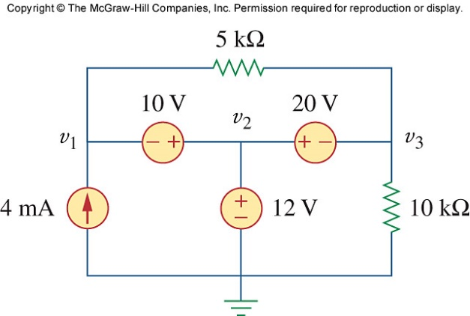
Figure 3.81
For Prob. 3.32.

